**Name : Ekesh Taneja  
Registration Number : 180953144  
CCE – 3**

LAB 1 RECORD

Q1

list1=[1,2,3,4,5,6,7,8,9,10];

list2=[11,12,13,14,15,16,17,18,19,20];

list3=[]

for i in list1 :

if i%2 != 0 :

list3.append(i)

for i in list2:

if i%2 == 0 :

list3.append(i)

print(list3)

SAMPLE INPUT/OUTPUT

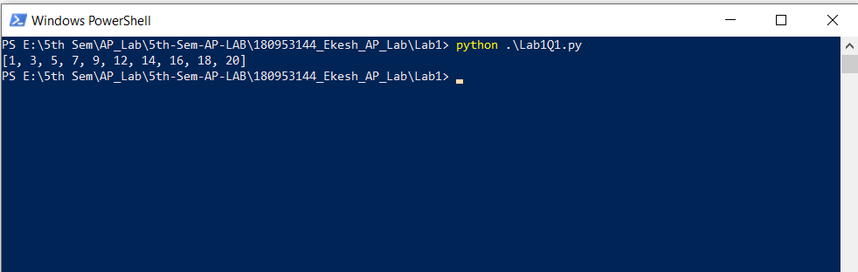

Q3

n = int(input("Enter number of elements:"))

c=0

odd_length=0

list_string=[]

odd_length_string=[]

for i in range(0,n):

list_string.append(input("Enter the string value:"))

if len(list_string[i])%2 != 0 :

odd_length+=1

odd_length_string.append(list_string[i])

for i in range(0,n):

if list_string[i][0] ==list_string[i][-1] and len(list_string[i]) >= 2 :

c+=1

print("The Number of Strings with same First and Last Character are:",c)

print("The Number of Strings with odd length are:",odd_length)

print("The Strings with Odd Length are :",odd_length_string)

SAMPLE INPUT/OUTPUT

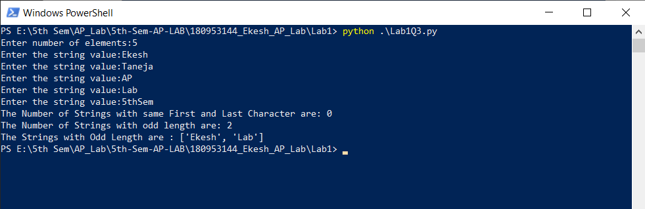

LAB 2 RECORD

Q1

import string

sentence = input("Enter a sentence:")

finalsentence = sentence.strip()

dict={}

dict['.']=1

for i in finalsentence :

if i in string.whitespace :

dict['.'] += 1

print(dict['.'])

SAMPLE INPUT/OUTPUT

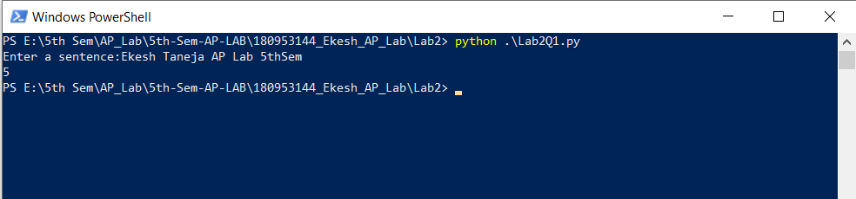

Q3.

import random

n=int(input("Enter number of elements:"))

dict={}

user_input= int(input("Enter the type of input-> 1:Integer 2:String:"))

if user_input == 1 :

avg=0

for i in range(0, n):

dict[random.randrange(0, 100)] = int(input("Enter a value : "))

for items in dict.values():

avg += items

avg/=len(dict)

print(avg)

elif user_input == 2 :

concat_string = ""

found=False

for i in range(0, n):

dict[random.randrange(0, 100)] = input("Enter a value : ")

search_element = input("Enter the element to search:")

for items in dict.values():

special_characters=True

concat_string+=items

for ch in items:

if ch.isalnum():

special_characters=False

if special_characters :

print(items)

if items == search_element:

found=True

print("Concatination:",concat_string)

print("Element Found:",found)

SAMPLE INPUT/OUTPUT

